

Handbook SmartBridge Educational Services Pvt. Ltd.

An Android Application for Keeping Up with the Latest Headlines :

The app's main feature is displaying a list of news articles, each with a title, image, and brief description. Users can scroll through the list of articles and tap on an article to view more details. The app uses the Jetpack Compose UI toolkit to build the UI and it uses the coil library to load images. The app fetches data from a remote server using Retrofit library and demonstrates how to use the Jetpack Compose UI toolkit for Android development.

# Architecture

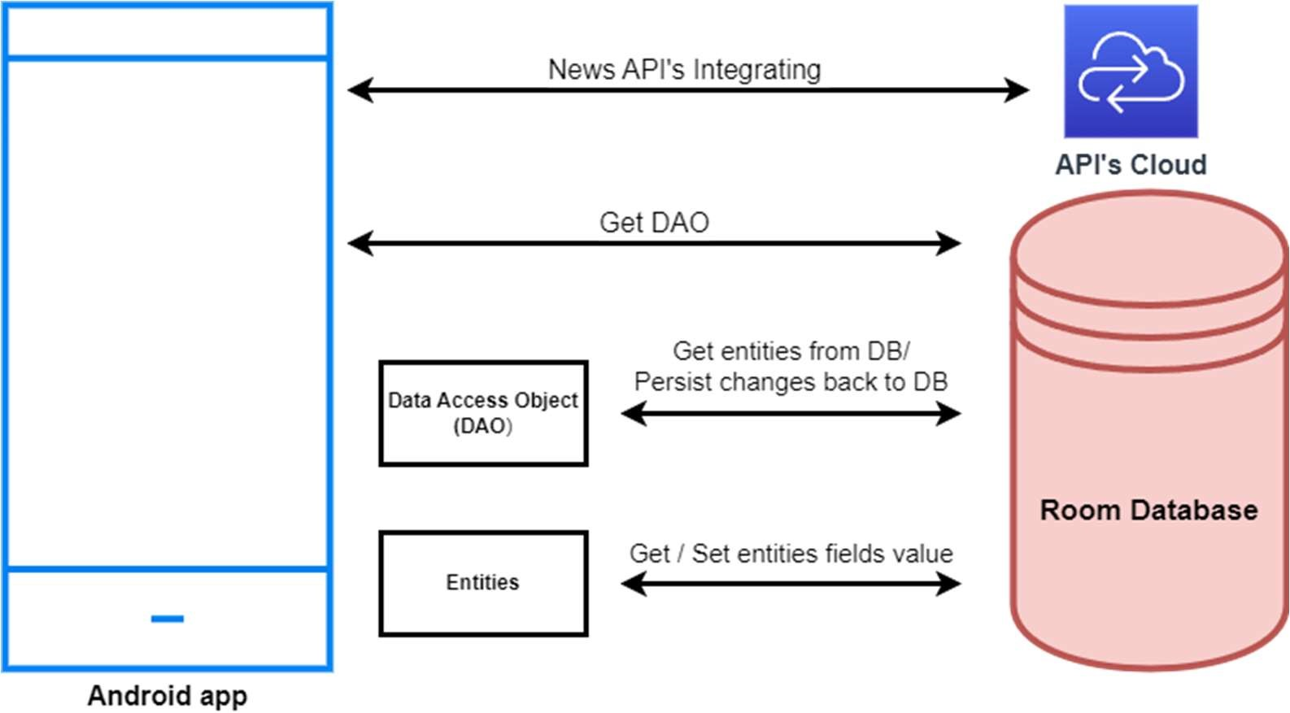

Learning Outcomes :

By end of this project:

* You’ll be able to work on Android studio and build an app.
* You’ll be able to integrate the database accordingly.
* You’ll be able to integrate the API’s accordingly.

Project Workflow:

* Users register into the application.
* After registration , user logins into the application.
* User enters into the main page

Tasks:

1. Creating a new project.
2. Adding required dependencies.
3. Adding permissions
4. Creating the database classes.
5. Creating API Service and required classes for integrating API
6. Building application UI and connecting to database.
7. Modifying AndroidManifest.xml
8. Running the application

Task 1 : Creating a new project.

Step 1 : Android studio > File > New > New Project > Empty Compose Activity

Step 2 : Click on Next button.

Step 3 : Give name to the new project.

Step 4 : Give the Minimum SDK value

Step 5 : Click Finish

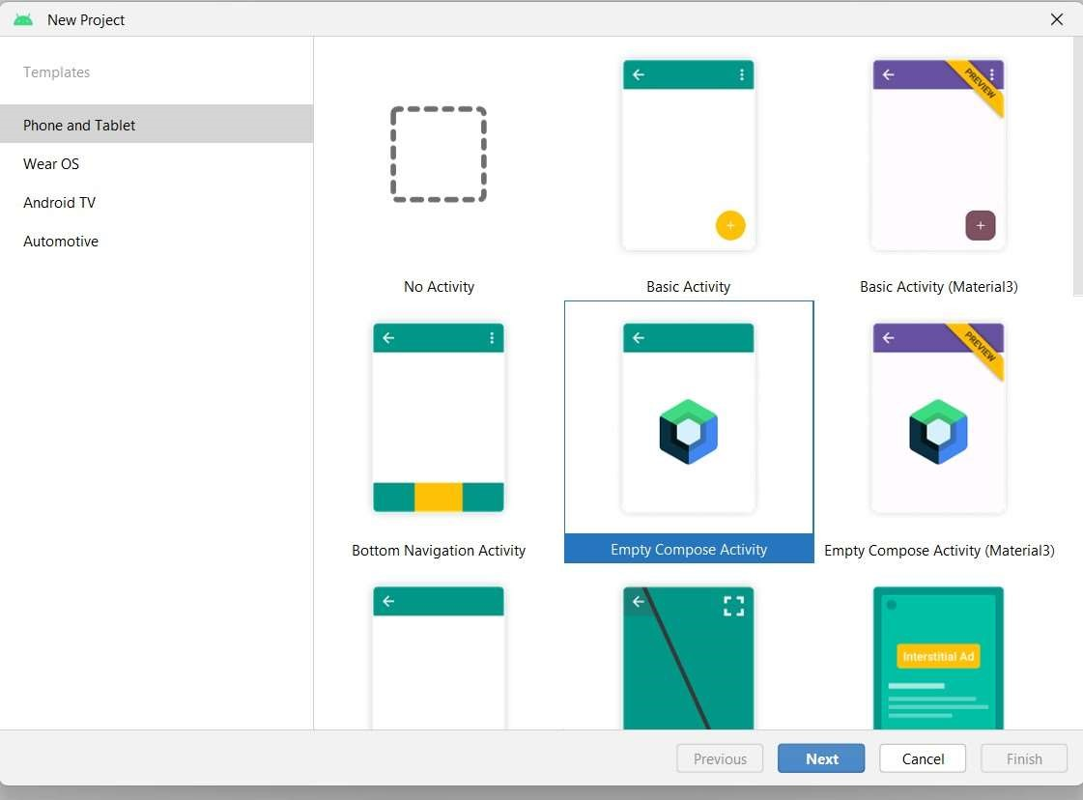

Task 2 : Adding required dependencies.

Step 1 : Gradle scripts > build.gradle(Module :app) Step 2 : Adding room dependencies.

Step 3 : Adding Retrofit dependencies

Step 4 : Adding Coil dependencies

Step 5 : Click on Sync now

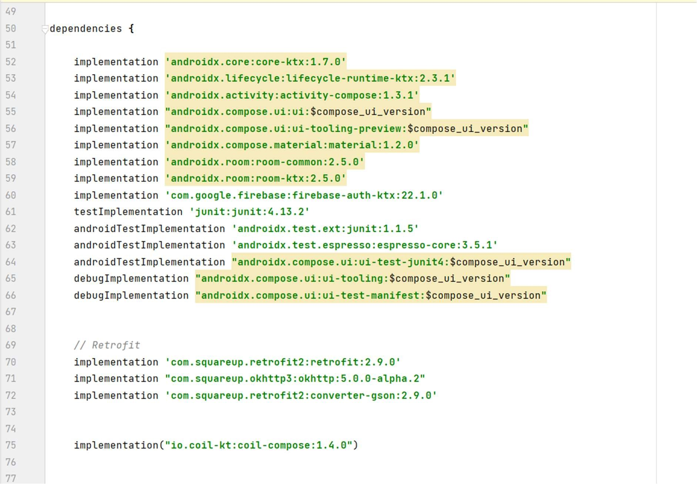

# Task 3: Adding permissions

Step 1: Open AndroidManifest.xml

Step 2: Add permission to access wifi and internet

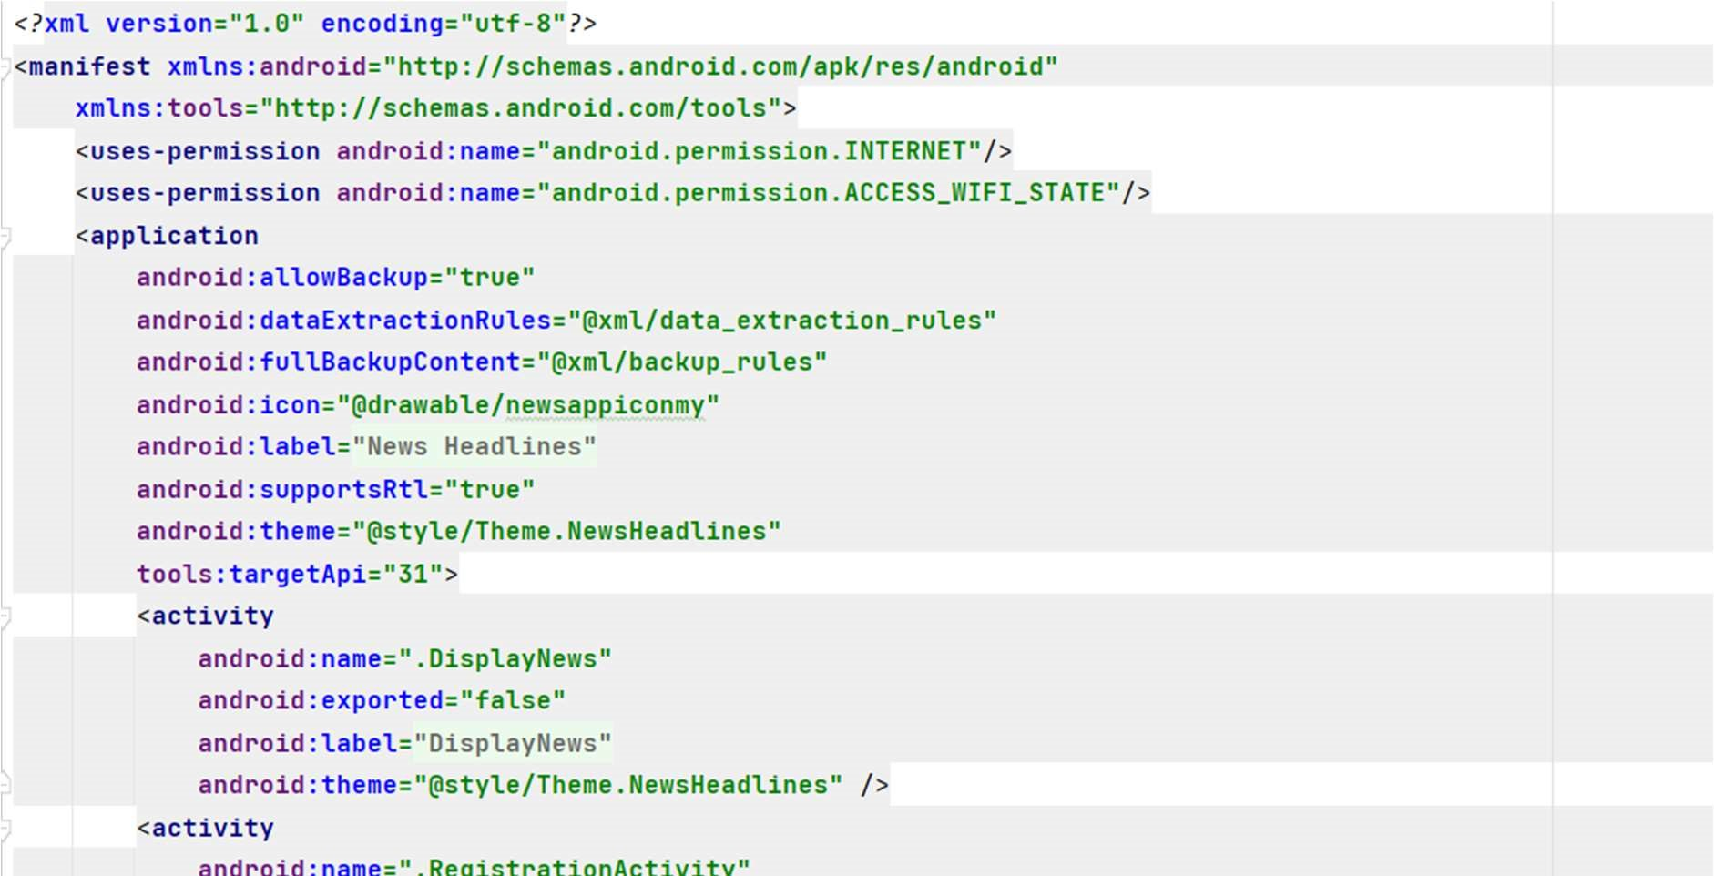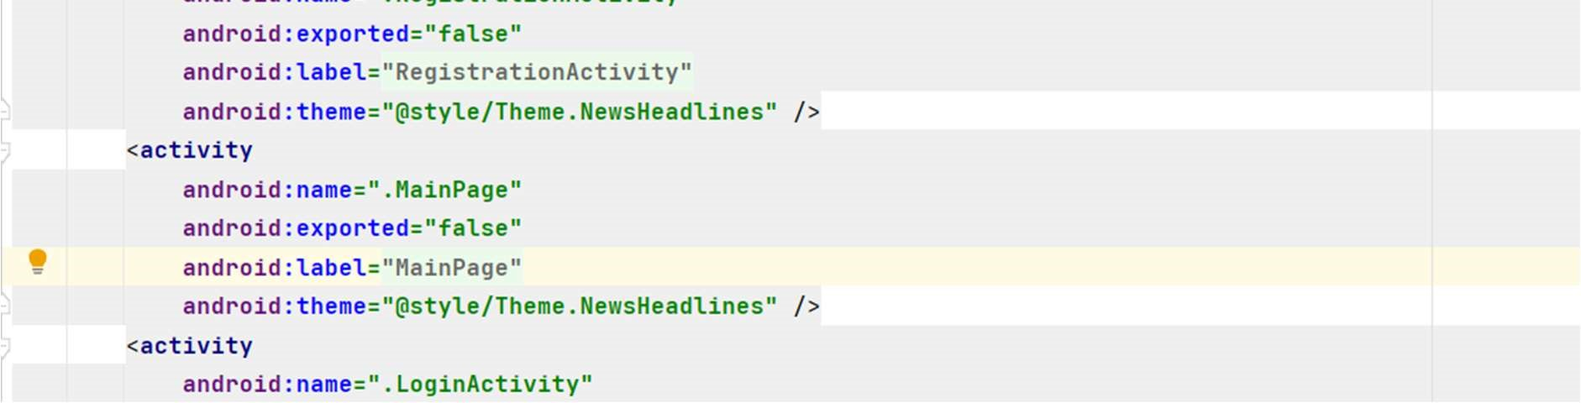

# Task 4: Creating the database classes

Step 1 : Create User data class

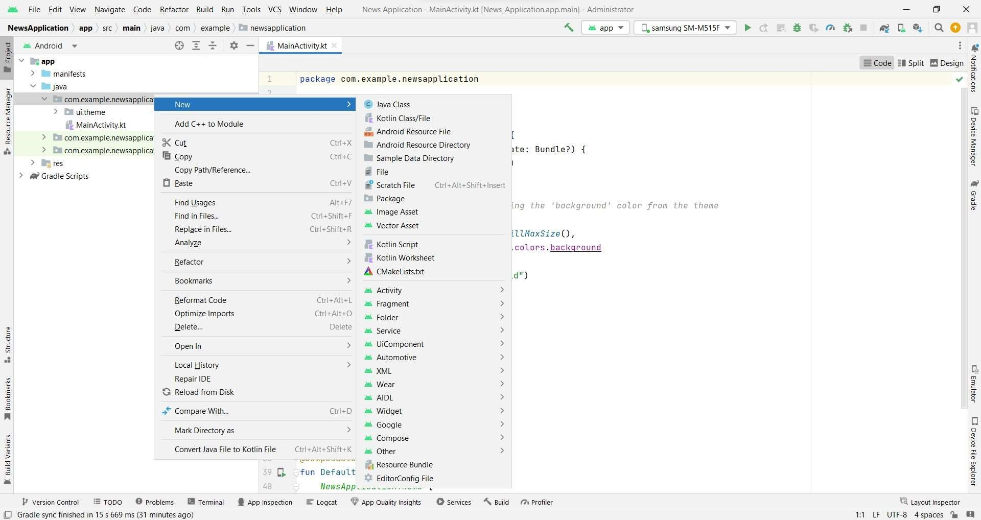

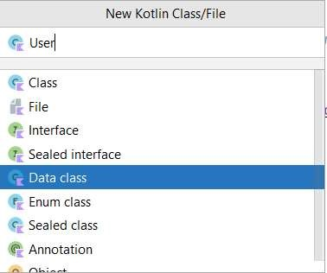

User class code: [An-Andriod-Appliction-for-keeping-up-with-the-latest-headlines/app/src/main/java/com/example/newsheadlines/User.kt at master · AMRUTHA72/An-Andriod-Appliction-for-keeping-up-with-the-latest-headlines (github.com)](https://github.com/AMRUTHA72/An-Andriod-Appliction-for-keeping-up-with-the-latest-headlines/blob/master/app/src/main/java/com/example/newsheadlines/User.kt)

# Step 2 : Create an UserDao interface

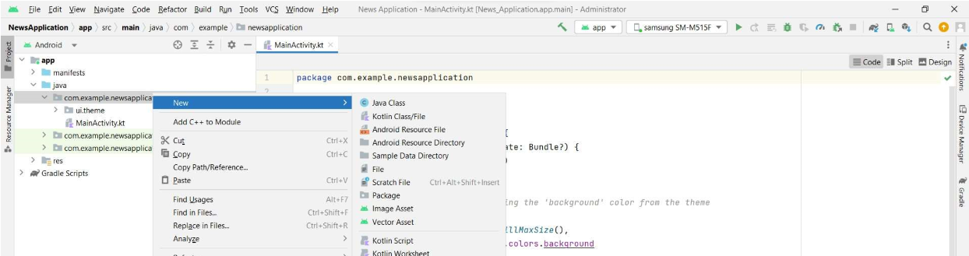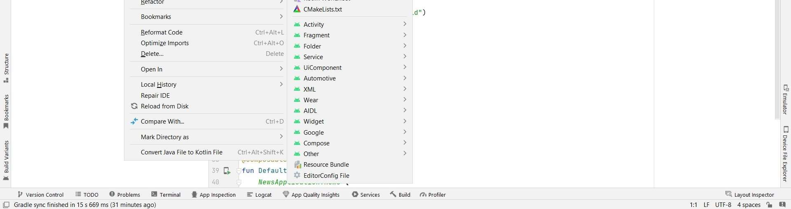

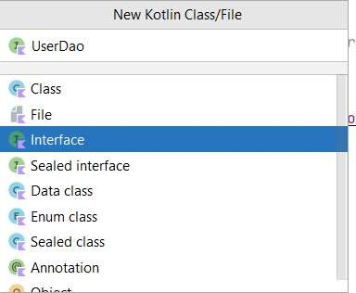

UserDao interface code: [An-Andriod-Appliction-for-keeping-up-with-the-latest-headlines/app/src/main/java/com/example/newsheadlines/UserDao.kt at master · AMRUTHA72/An-Andriod-Appliction-for-keeping-up-with-the-latest-headlines (github.com)](https://github.com/AMRUTHA72/An-Andriod-Appliction-for-keeping-up-with-the-latest-headlines/blob/master/app/src/main/java/com/example/newsheadlines/UserDao.kt)

# Step 3 : Create an UserDatabase class

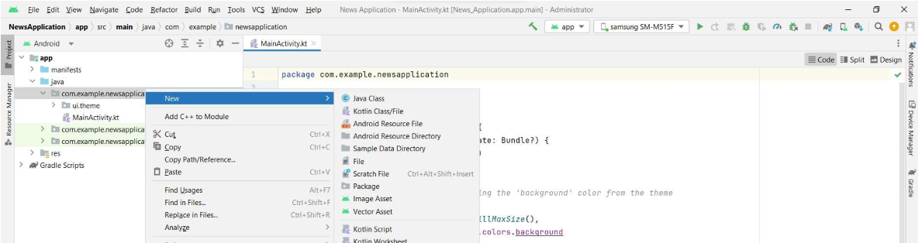

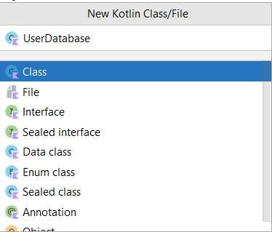

UserDatabase class code: [An-Andriod-Appliction-for-keeping-up-with-the-latest-headlines/app/src/main/java/com/example/newsheadlines/UserDatabase.kt at master · AMRUTHA72/An-Andriod-Appliction-for-keeping-up-with-the-latest-headlines (github.com)](https://github.com/AMRUTHA72/An-Andriod-Appliction-for-keeping-up-with-the-latest-headlines/blob/master/app/src/main/java/com/example/newsheadlines/UserDatabase.kt)

Step 4 : Create an UserDatabaseHelper class:

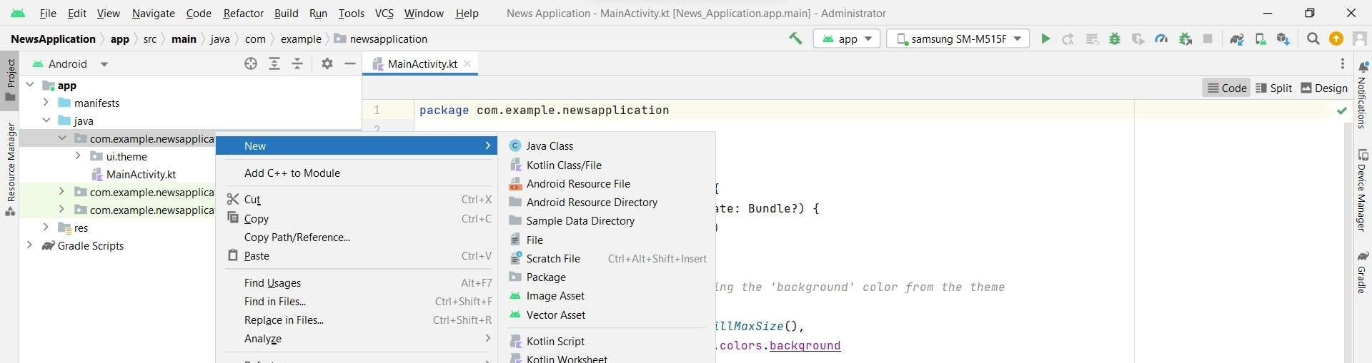

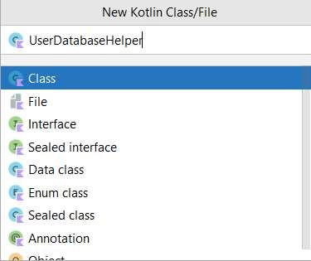

UserDatabaseHelper class code : [An-Andriod-Appliction-for-keeping-up-with-the-latest-headlines/app/src/main/java/com/example/newsheadlines/UserDatabaseHelper.kt at master · AMRUTHA72/An-Andriod-Appliction-for-keeping-up-with-the-latest-headlines (github.com)](https://github.com/AMRUTHA72/An-Andriod-Appliction-for-keeping-up-with-the-latest-headlines/blob/master/app/src/main/java/com/example/newsheadlines/UserDatabaseHelper.kt)

# Task 6 :Creating API Service and required classes for integrating API

Step 1: Create a API key for the required API

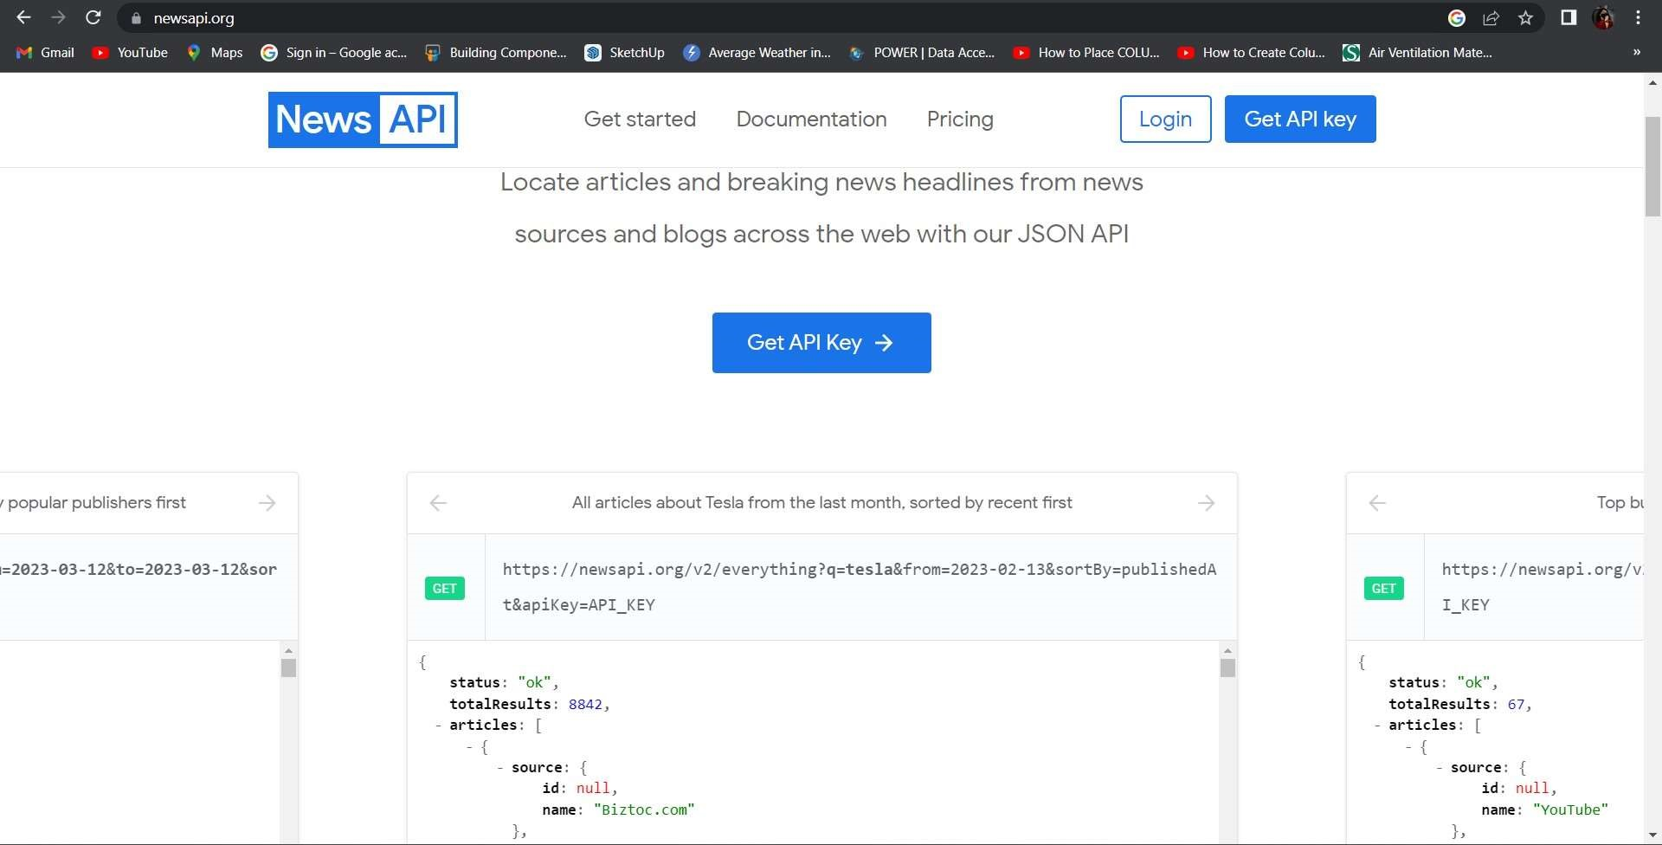

Code which is needed to be copied:

https://newsapi.org/v2/top-

headlines?country=in&apiKey=aeff87a82995467d95eb4350a7349a18

Database for news integration into project

Step 3: Create ApiService interface

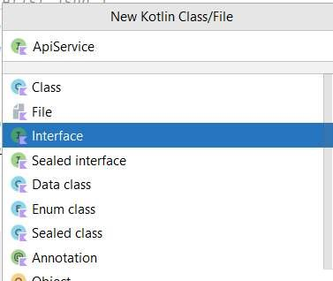

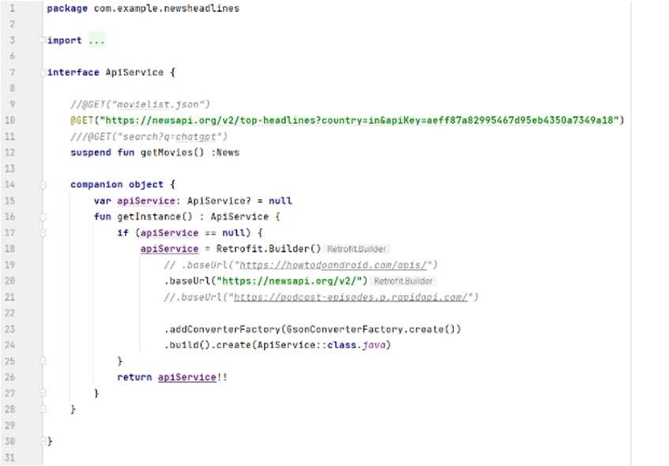

ApiService interface code: [An-Andriod-Appliction-for-keeping-up-with-the-latest-headlines/app/src/main/java/com/example/newsheadlines/ApiService.kt at master · AMRUTHA72/An-Andriod-Appliction-for-keeping-up-with-the-latest-headlines (github.com)](https://github.com/AMRUTHA72/An-Andriod-Appliction-for-keeping-up-with-the-latest-headlines/blob/master/app/src/main/java/com/example/newsheadlines/ApiService.kt)

# Step 4: Create Model data class

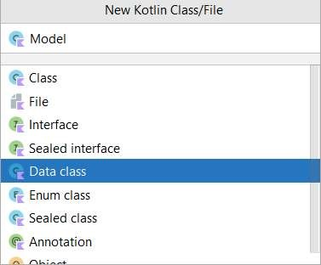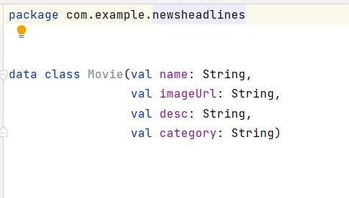

Model class code: [An-Andriod-Appliction-for-keeping-up-with-the-latest-headlines/app/src/main/java/com/example/newsheadlines/Model.kt at master · AMRUTHA72/An-Andriod-Appliction-for-keeping-up-with-the-latest-headlines (github.com)](https://github.com/AMRUTHA72/An-Andriod-Appliction-for-keeping-up-with-the-latest-headlines/blob/master/app/src/main/java/com/example/newsheadlines/Model.kt)

# Step 5: Create News data class



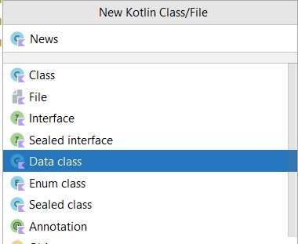

News Data Class Code: [An-Andriod-Appliction-for-keeping-up-with-the-latest-headlines/app/src/main/java/com/example/newsheadlines/News.kt at master · AMRUTHA72/An-Andriod-Appliction-for-keeping-up-with-the-latest-headlines (github.com)](https://github.com/AMRUTHA72/An-Andriod-Appliction-for-keeping-up-with-the-latest-headlines/blob/master/app/src/main/java/com/example/newsheadlines/News.kt)

Step 6: Create Source data class:



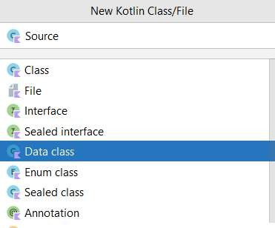

Source data class code:

[An-Andriod-Appliction-for-keeping-up-with-the-latest-headlines/app/src/main/java/com/example/newsheadlines/Source.kt at master · AMRUTHA72/An-Andriod-Appliction-for-keeping-up-with-the-latest-headlines (github.com)](https://github.com/AMRUTHA72/An-Andriod-Appliction-for-keeping-up-with-the-latest-headlines/blob/master/app/src/main/java/com/example/newsheadlines/Source.kt)

Step 7: Create Articles data class



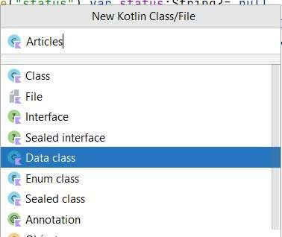

Articles data code:

[An-Andriod-Appliction-for-keeping-up-with-the-latest-headlines/app/src/main/java/com/example/newsheadlines/Articles.kt at master · AMRUTHA72/An-Andriod-Appliction-for-keeping-up-with-the-latest-headlines (github.com)](https://github.com/AMRUTHA72/An-Andriod-Appliction-for-keeping-up-with-the-latest-headlines/blob/master/app/src/main/java/com/example/newsheadlines/Articles.kt)

Step 8: Create MainViewModel class



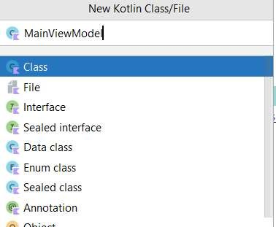

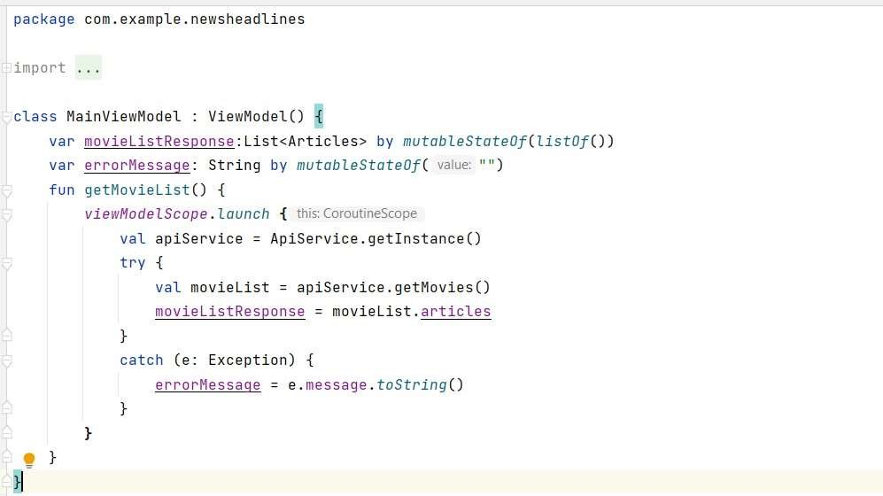

Main view model class code:

[An-Andriod-Appliction-for-keeping-up-with-the-latest-headlines/app/src/main/java/com/example/newsheadlines/MainViewModel.kt at master · AMRUTHA72/An-Andriod-Appliction-for-keeping-up-with-the-latest-headlines (github.com)](https://github.com/AMRUTHA72/An-Andriod-Appliction-for-keeping-up-with-the-latest-headlines/blob/master/app/src/main/java/com/example/newsheadlines/MainViewModel.kt)

Task 7:Building application UI and connecting to database.

Step 1: Creating LoginActivity.kt with database

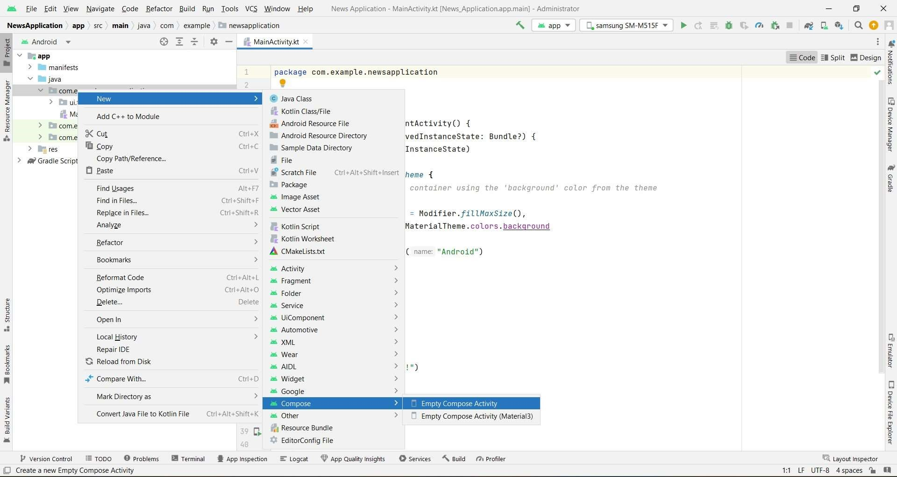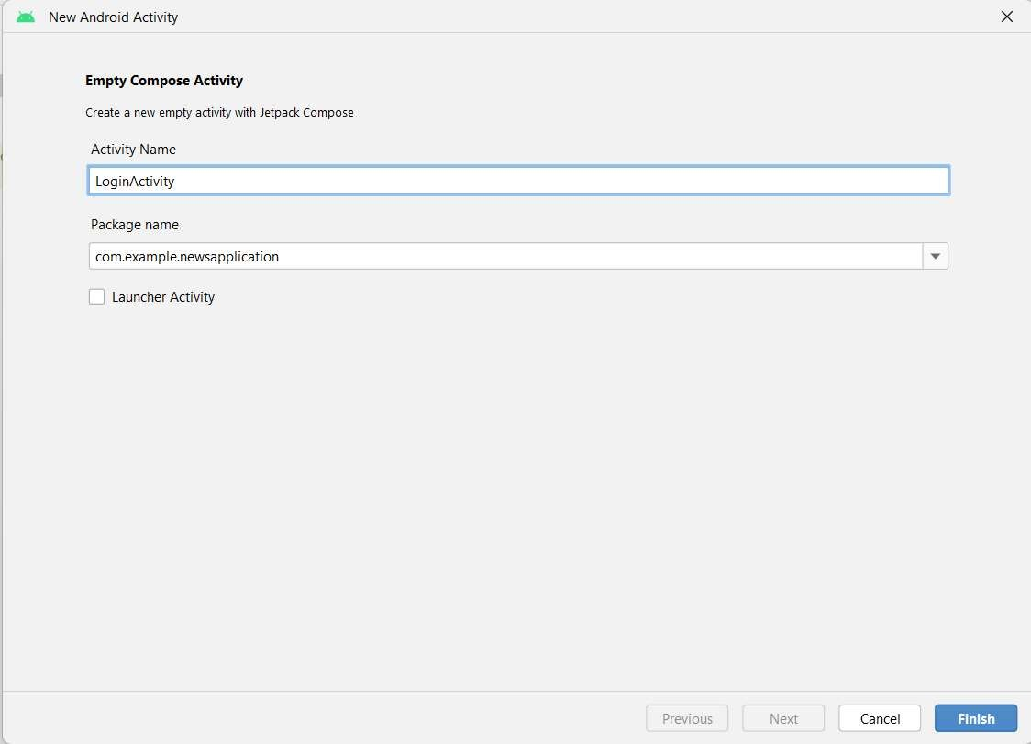

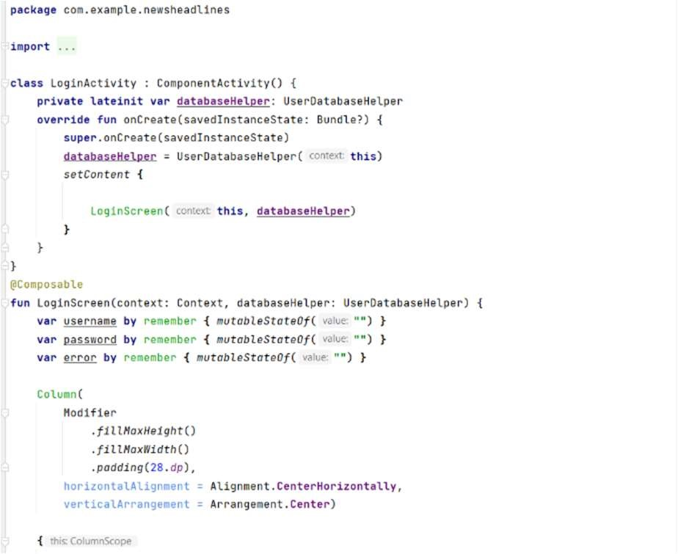

Loginactivity code:

[An-Andriod-Appliction-for-keeping-up-with-the-latest-headlines/app/src/main/java/com/example/newsheadlines/LoginActivity.kt at master · AMRUTHA72/An-Andriod-Appliction-for-keeping-up-with-the-latest-headlines (github.com)](https://github.com/AMRUTHA72/An-Andriod-Appliction-for-keeping-up-with-the-latest-headlines/blob/master/app/src/main/java/com/example/newsheadlines/LoginActivity.kt)

Step 2 : Creating RegistrationActivity.kt with database

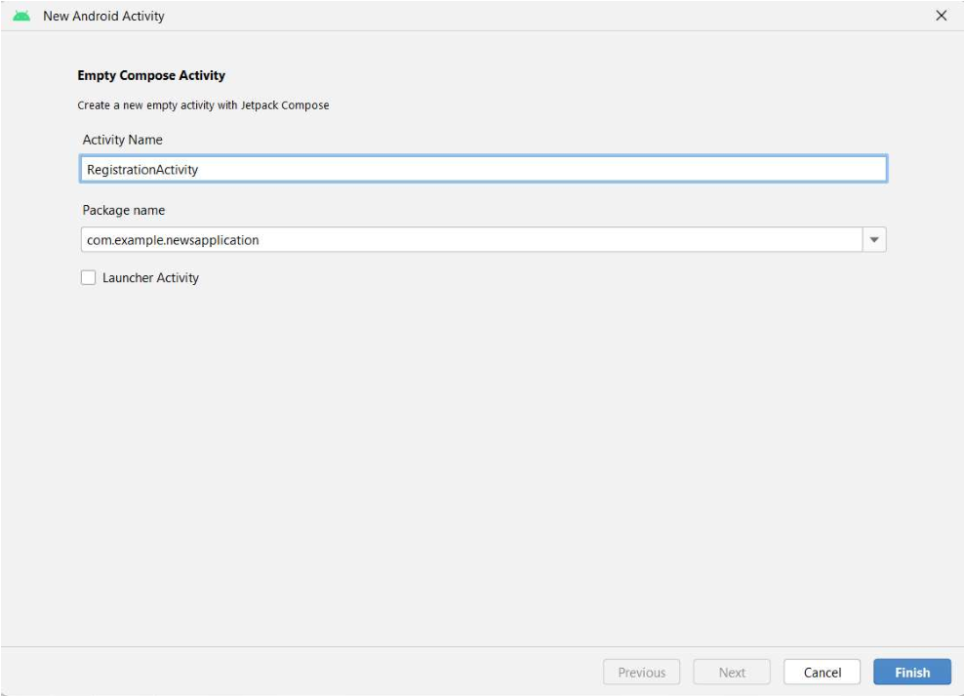

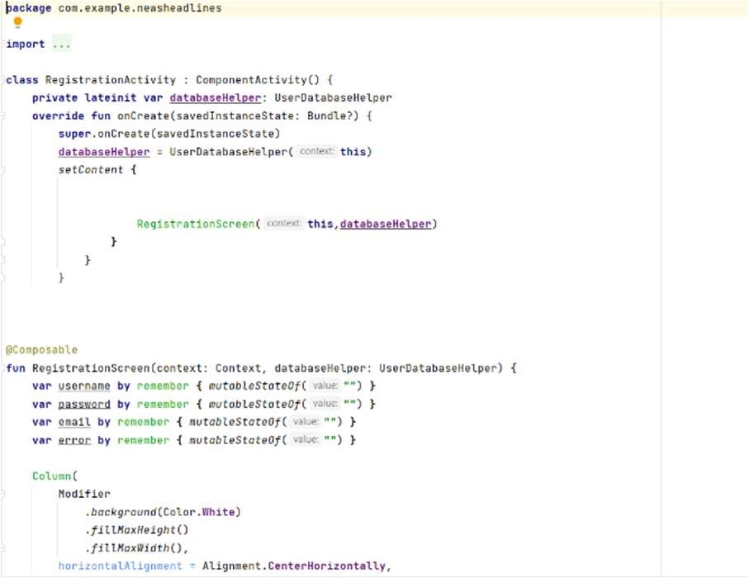

Registration Activity code: [An-Andriod-Appliction-for-keeping-up-with-the-latest-headlines/app/src/main/java/com/example/newsheadlines/RegistrationActivity.kt at master · AMRUTHA72/An-Andriod-Appliction-for-keeping-up-with-the-latest-headlines (github.com)](https://github.com/AMRUTHA72/An-Andriod-Appliction-for-keeping-up-with-the-latest-headlines/blob/master/app/src/main/java/com/example/newsheadlines/RegistrationActivity.kt)

# Step 3 : Creating MainActivity.kt file

In MainActivity.kt file the main application is developed

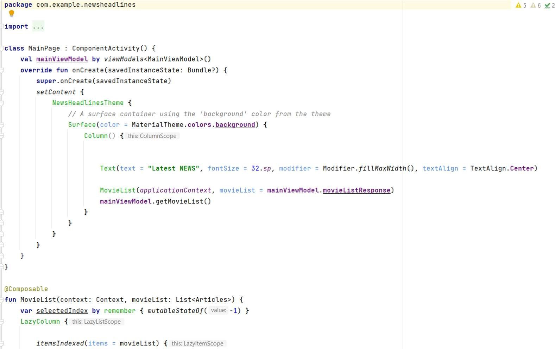

Main page activity code:

[An-Andriod-Appliction-for-keeping-up-with-the-latest-headlines/app/src/main/java/com/example/newsheadlines/MainPage.kt at master · AMRUTHA72/An-Andriod-Appliction-for-keeping-up-with-the-latest-headlines (github.com)](https://github.com/AMRUTHA72/An-Andriod-Appliction-for-keeping-up-with-the-latest-headlines/blob/master/app/src/main/java/com/example/newsheadlines/MainPage.kt)

Step 4 : Creating DisplayNews.kt file

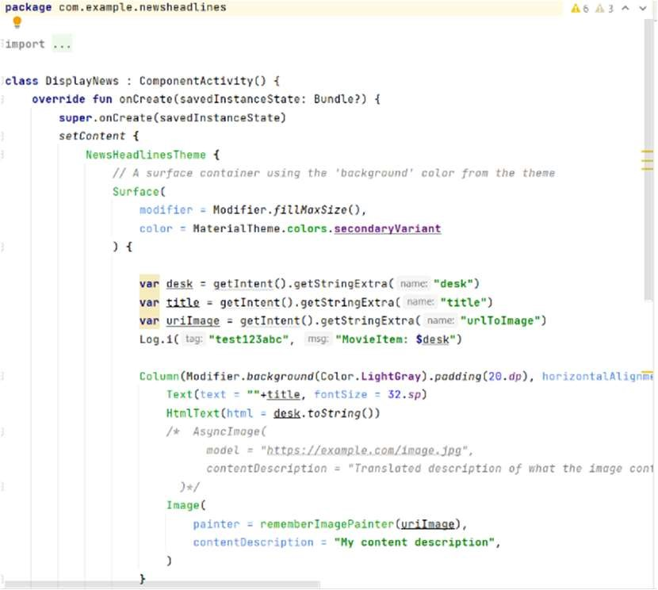

Display news code:

# [An-Andriod-Appliction-for-keeping-up-with-the-latest-headlines/app/src/main/java/com/example/newsheadlines/DisplayNews.kt at master · AMRUTHA72/An-Andriod-Appliction-for-keeping-up-with-the-latest-headlines (github.com)](https://github.com/AMRUTHA72/An-Andriod-Appliction-for-keeping-up-with-the-latest-headlines/blob/master/app/src/main/java/com/example/newsheadlines/DisplayNews.kt)

# Task 8: Modifying AndroidManifest.xml

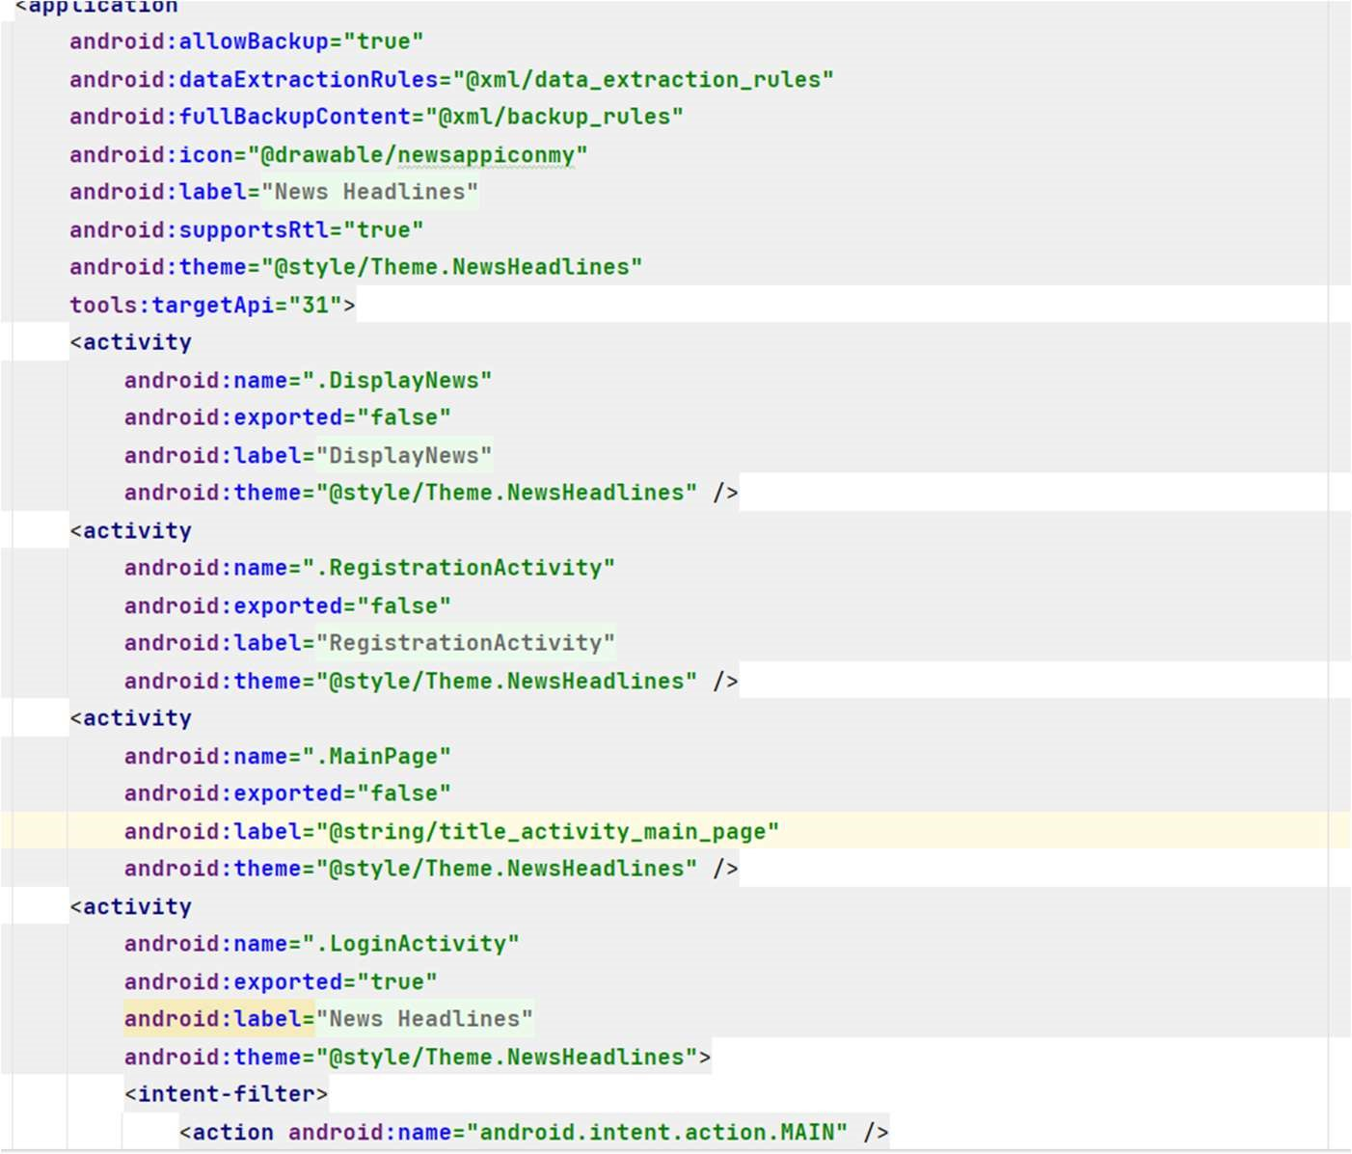

Complete Code is given:

[An-Andriod-Appliction-for-keeping-up-with-the-latest-headlines/app/src/main/AndroidManifest.xml at master · AMRUTHA72/An-Andriod-Appliction-for-keeping-up-with-the-latest-headlines (github.com)](https://github.com/AMRUTHA72/An-Andriod-Appliction-for-keeping-up-with-the-latest-headlines/blob/master/app/src/main/AndroidManifest.xml)

Task 9 : Running app on the hardware For the tutorial click the below link:

<https://developer.android.com/studio/run/device>

Run Application on the emulator:



For Complete Project Link: [AMRUTHA72/An-Andriod-Appliction-for-keeping-up-with-the-latest-headlines (github.com)](https://github.com/AMRUTHA72/An-Andriod-Appliction-for-keeping-up-with-the-latest-headlines)

Login Page:

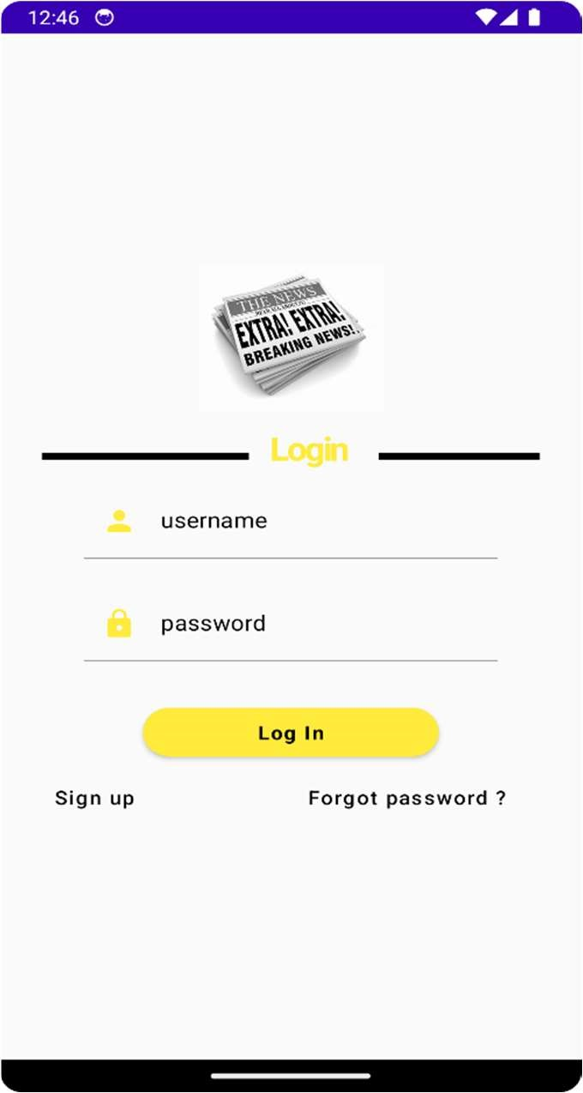

Signup Page:

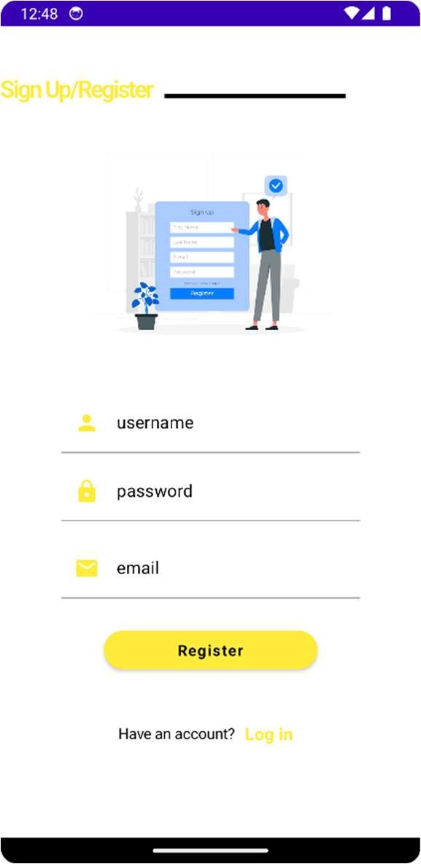

Main Page:

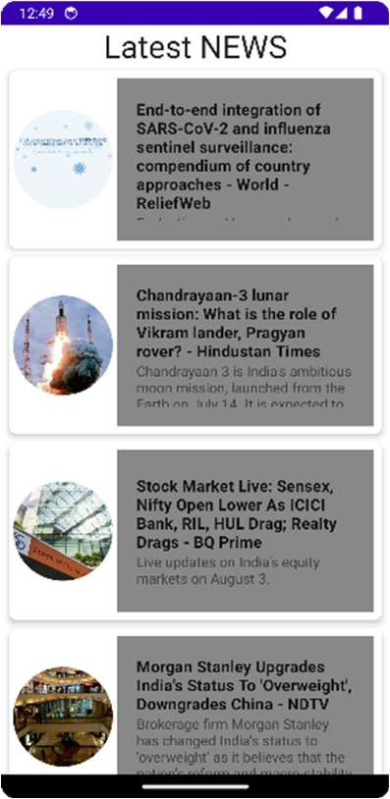

News View Page:

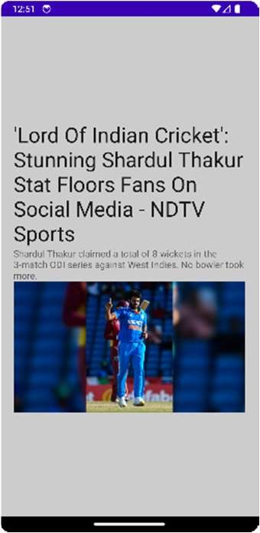

Submitted By:

Team ID : LTVIP2023TMID04349

Team Size : 4

Team Leader : Sreenivasulu Gariamrutha

Team member : Sodinapalli Saikumarreddy

Team member : Thammishetty PraveenKumar

Team member : Thota Muralikrishna